Ideation Phase
Brainstorm & Idea Prioritization Template

Date | 26 October 2026
Team ID
Project Name | HotelPro – Complete Hotel Booking and Management Solution
Maximum Marks | 4 Marks

Brainstorm & Idea Prioritization Template:
Brainstorming provides a collaborative environment where team members can share ideas, explore creative possibilities, and develop potential solutions to the challenges faced by hotel guests and hotel staff. For HotelPro, this process encourages participants to think beyond conventional approaches and propose innovative ways to improve room search, real-time availability tracking, secure online booking and payment, and hotel operations management.
The process emphasizes generating a wide range of ideas before evaluating them, allowing team members to build upon one another's suggestions and explore different approaches. These ideas will subsequently be grouped and prioritized according to their potential impact and implementation feasibility, helping the team identify promising features for HotelPro and guide its further development.
Step-1: Team Gathering, Collaboration and Select the Problem Statement
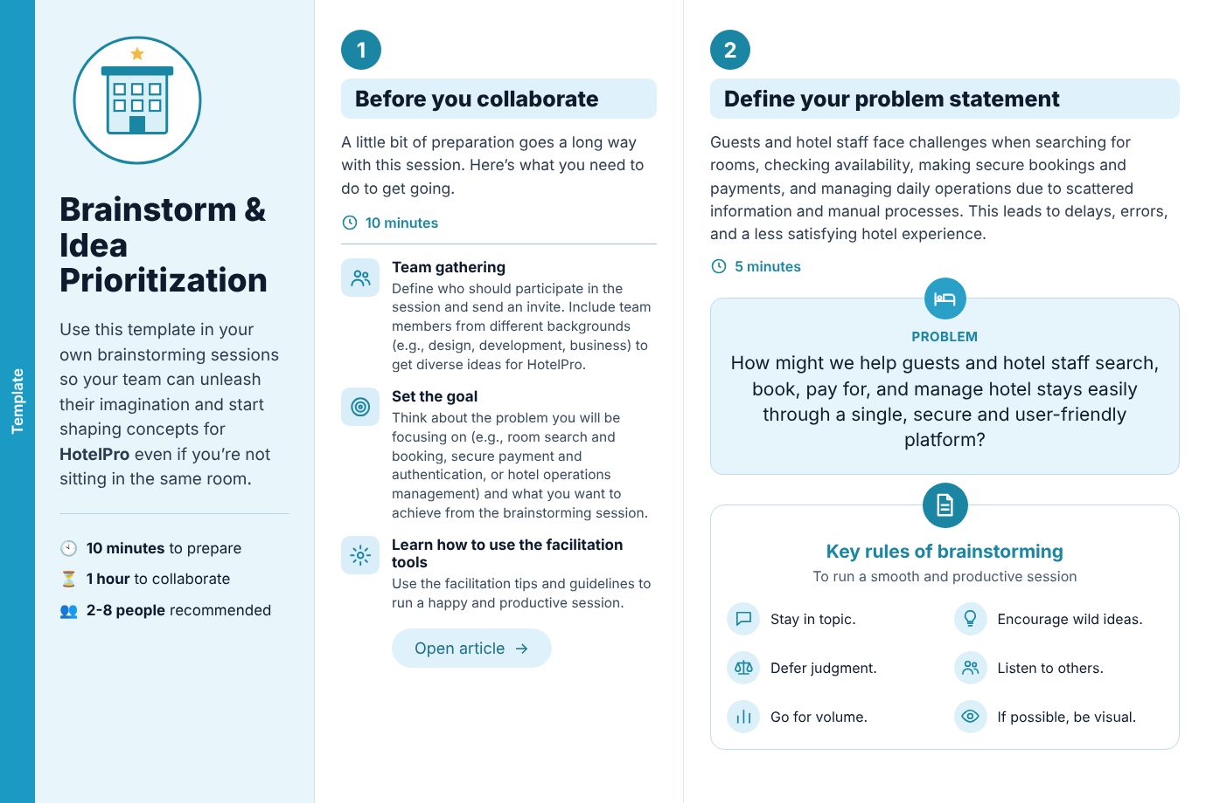

Step-2: Brainstorm, Idea Listing and Grouping
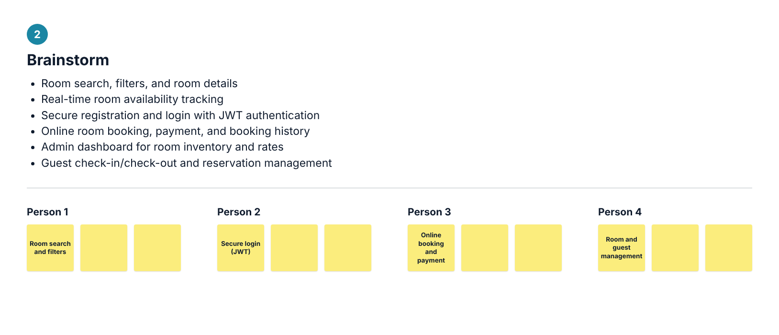
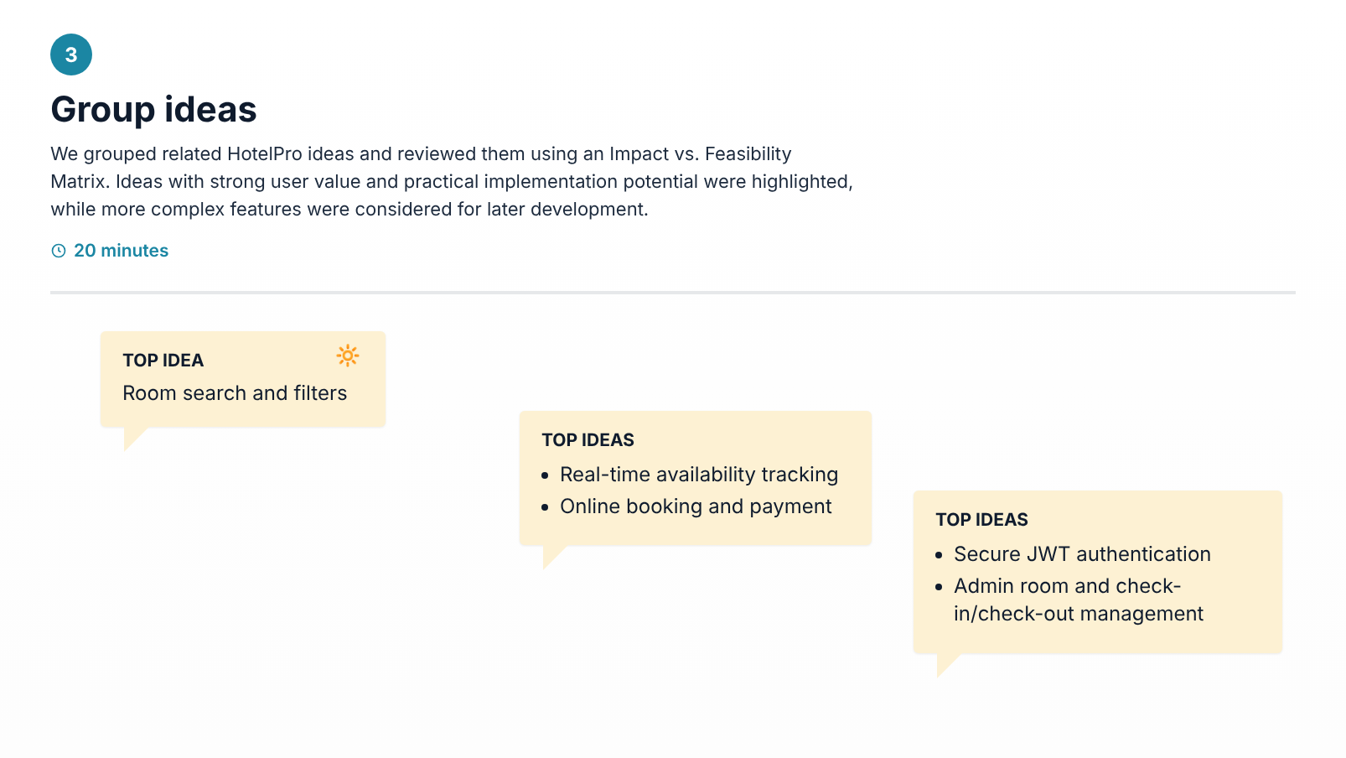

Step-3: Idea Prioritization
